Aleluya, Pagdaygon Ang Dios | Mass_Song | Lyrics and Chords

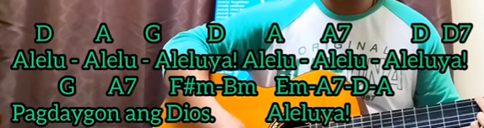
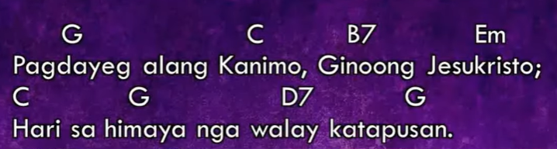

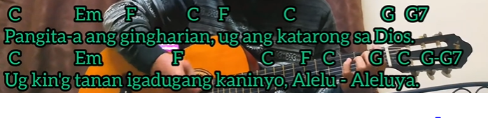
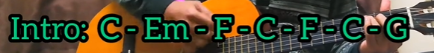

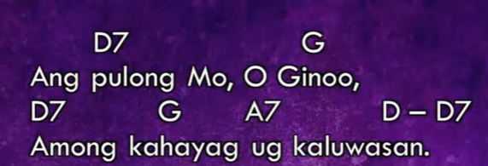
Intro: C-G-D7-G

